**EMERGING METHODS FOR EARLY DETECTION OF FOREST FIRE**

**TEAM ID:PNT2022TMID27778**

**Video Analysis**

**OpenCV For Video Processing**

OpenCV is an open-source library that provides us with the tools to perform almost any kind of image and video processing.

**Task 1: Capture Video from Camera**

Often, we have to capture the live stream with a camera. OpenCV provides a very simple interface to this. Let’s capture a video from the camera (I am using the in-built webcam of my laptop), convert it into grayscale video, and display it.

To capture a video, you need to create a **VideoCapture** object. Its argument can be either the device index or the name of a video file. The device index is just the number to specify which camera. Normally one camera will be connected (as in my case). So I simply pass 0 (or -1). You can select the second camera by passing 1 and so on. After that, you can capture frame-by-frame. But in the end, don’t forget to release the capture. To read web cam will see the code.

**Task 2: Importing the required libraries.**

Install Twilio library, run the below command in anaconda prompt,

 “pip install twilio”.

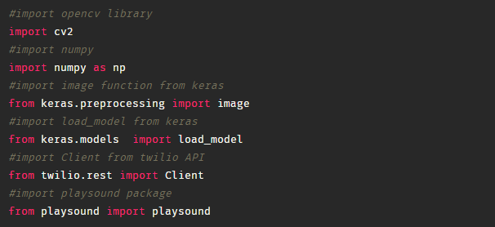

**Task 3: Loading our saved model file using load_model from Keras library**

### image17.png

### Creating An Account In Twilio Service

**Task 1: Use API to send messages.**

We got the Account SID and Authentication token from Twilio. Now we integrate Twilio to send an alert message.

To integrate it with python, refer to the code

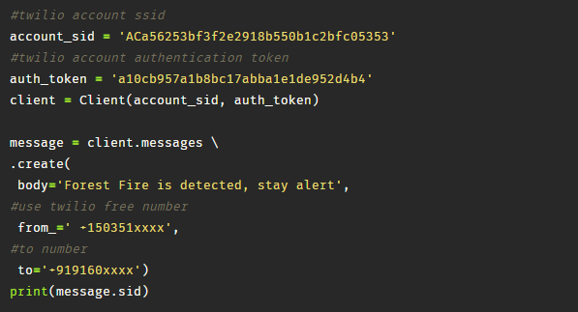

### Sending Alert Message

To play an alerting sound we need to install **"playsound"** library.

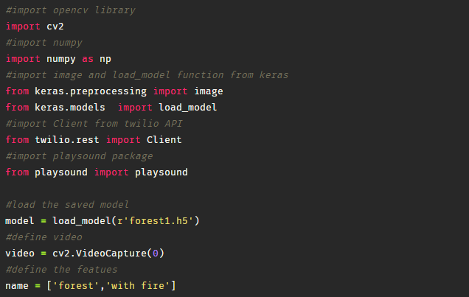

NEXT

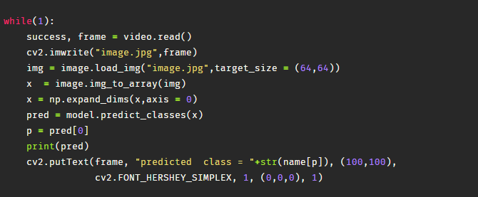

**NEXT**

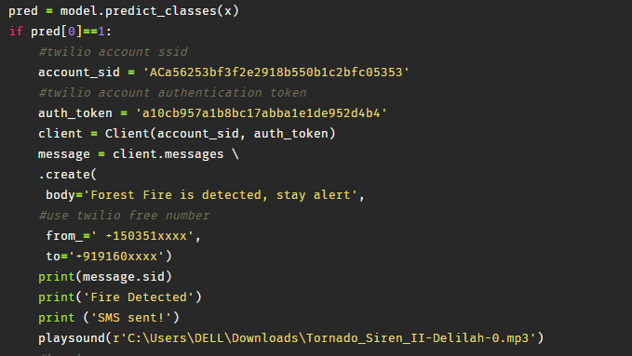

**NEXT**

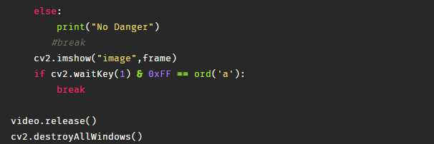

Once you run the above code, after loading your model, and the label names (classes) that you have considered in the project, and also the authentication token and Account SID from Twilio, This will open one video frame pop up on your desktop/laptop screen.

Now we provide with different test images of a forest fire or normal forest images, the model detects, if there is any forest fire in the video stream. If the forest fire is detected then an alert message will be sent to higher authorities and with a sound, else it returns no danger.

